
LESSON NOTE | DETAILED EXPLANATORY NOTES

SCIENTIFIC INQUIRY & METHODOLOGY
Scientific Method & Inquiry Skills

GRADE 12- BIOLOGY

■ ■ ■

What is Science as Inquiry?
Science as inquiry refers to the process of investigating the natural world through observation, questioning, experimentation, and evidence-based reasoning. Rather than simply memorizing facts, scientists actively seek explanations for natural phenomena by asking questions, designing fair tests, gathering evidence, analyzing data, and drawing conclusions based on the results obtained.
Science as inquiry is the foundation of biology and all other scientific disciplines. Before we can understand concepts such as DNA, photosynthesis, ecosystems, or human health, we must first understand how scientists discovered and verified this knowledge. Scientific inquiry encourages curiosity, critical thinking, problem-solving, and informed decision-making, which are essential skills both inside and outside the classroom.
Scientific inquiry is an ongoing process. Scientists often refine their ideas, repeat investigations, and gather additional evidence as new questions arise. Therefore, scientific knowledge continues to develop and improve over time.

The Skills of Scientific Inquiry
Scientific inquiry involves a set of interconnected skills that help scientists investigate questions and solve problems systematically:
- Questioning and Predicting - Asking testable scientific questions and developing hypotheses or predictions based on observations.
- Planning and Investigating - Designing fair and controlled investigations to collect reliable evidence.
- Processing and Analyzing - Organizing, presenting, and interpreting data using tables, graphs, and other methods.
- Evaluating - Assessing the reliability, accuracy, and validity of results and identifying possible improvements.
- Communicating - Reporting findings clearly, accurately, and honestly using scientific language and appropriate formats.

Scientific Method & Inquiry Skills

Key Points (Learning Outcomes)
- Describe the steps of the scientific method and explain why it is a cycle, not a straight line.
- Write a testable hypothesis and a matching prediction.
- Identify the independent, dependent and controlled variables in an investigation.
- Distinguish reliability, accuracy and validity, and the role of a control.
- Organize data into tables and graphs and interpret trends.
- Write a structured scientific report and communicate results.

What is the Scientific Method?
The scientific method is a systematic and organized approach used to investigate questions about the natural world. It allows scientists to gather evidence, test ideas, and develop explanations based on observations and experimental results. By following a logical process, scientists can ensure that their investigations are fair, reliable, and based on evidence rather than personal opinions or assumptions.
The scientific method typically begins with an observation, which leads to a question. Scientists then develop a hypothesis, make a prediction, conduct an experiment, collect and analyze data, and draw a conclusion based on the evidence obtained. The conclusion helps determine whether the hypothesis is supported or needs to be revised.
Although the scientific method is often shown as a series of steps, it is not a rigid, one-way process. Scientific investigations are frequently repeated, modified, or expanded as new evidence becomes available. Unexpected results may lead scientists to revise their hypotheses, improve their methods, or investigate new questions. For this reason, the scientific method is best represented as a continuous cycle of inquiry and discovery.
Through the scientific method, scientists can build reliable knowledge, solve problems, and improve our understanding of biological systems and the world around us.

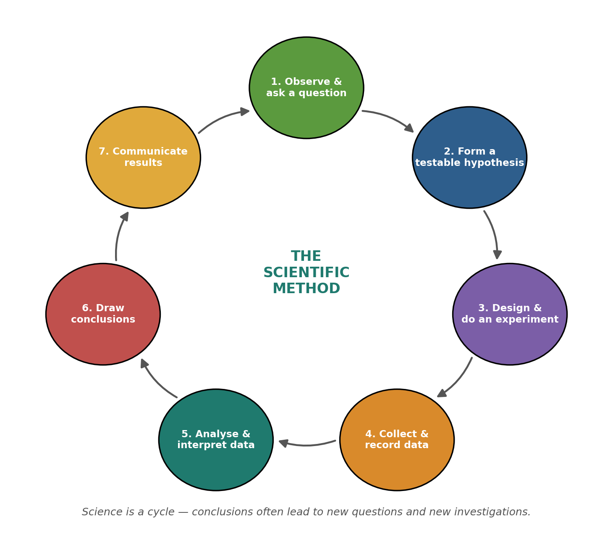

Figure 1: The scientific method as a cycle - observation, hypothesis, experiment, conclusion, and back again.

Inquiry Skills - Terminologies and Concepts
Understanding scientific inquiry requires familiarity with several key terms used in investigations and experiments.
- Observation: The process of noticing and describing events, objects, or patterns in the natural world using the senses or scientific instruments. Observations often lead to scientific questions and investigations.
- Hypothesis: A testable and tentative explanation for an observation or scientific question. A good hypothesis is based on existing knowledge and can be supported or rejected through investigation.
- Prediction: A statement describing what is expected to happen if the hypothesis is correct. Predictions are often written in an “If... then...” format.
- Independent Variable: The factor that is deliberately changed or manipulated by the investigator during an experiment.
- Dependent Variable: The factor that is measured, observed, or recorded as a result of changes made to the independent variable.
- Controlled Variables: Factors that are kept constant throughout an investigation to ensure that the test remains fair and that only the independent variable affects the outcome.
- Control Group: A comparison group that does not receive the treatment or experimental condition. It provides a baseline against which the results of the experimental group can be compared.
- Reliability: The degree to which an investigation produces consistent results when repeated under the same conditions. Reliability is improved by repeating trials and calculating averages.
- Validity: The extent to which an investigation accurately tests what it is intended to test. A valid investigation controls variables and uses appropriate methods to answer the research question.
- Accuracy: The closeness of a measurement to the true or accepted value. Accurate measurements help improve the quality and credibility of scientific investigations.
- Qualitative Data: Descriptive information collected through observations using words rather than numbers. Examples include colour, texture, shape, and behaviour.
- Quantitative Data: Numerical information collected through measurement or counting. Examples include height, mass, temperature, and time.
- Error: Any factor that may affect the accuracy or reliability of results. Errors can arise from human mistakes, equipment limitations, or environmental influences.
- Bias: A systematic influence that may affect the fairness or objectivity of an investigation, leading to inaccurate conclusions.

The Hypothesis and Prediction
A hypothesis is a proposed explanation for an observation or scientific question that can be tested through investigation. A good hypothesis should be clear, specific, and based on existing knowledge or observations. Most importantly, it must be testable, meaning that evidence can be collected to support or reject it.
For example, a student investigating photosynthesis may propose the hypothesis: “Increasing light intensity increases the rate of photosynthesis.” This statement can be tested by measuring the rate of oxygen production under different light conditions.
From a hypothesis, scientists develop a prediction. A prediction describes the expected outcome of an investigation if the hypothesis is correct and is often written in an “If... then...” format. For example:

Hypothesis: Increasing light intensity increases the rate of photosynthesis.
Prediction: If light intensity increases, then the rate of oxygen bubble production by the plant will increase.
It is important to note that scientific investigations do not prove a hypothesis to be true. Instead, evidence either supports or does not support the hypothesis. A hypothesis that cannot be tested or potentially proven wrong is not considered scientific.

Variables and the Fair Test
A scientific investigation is considered a fair test when only one factor is changed at a time while all other relevant factors are kept constant. This ensures that any observed changes in the results are caused by the factor being tested rather than by other influences.
The factor that is deliberately changed by the investigator is called the independent variable. The factor that is measured or observed in response to this change is called the dependent variable. All other factors that could affect the outcome must be kept constant and are known as controlled variables.
In some investigations, a control group is used. The control group does not receive the treatment or experimental condition and serves as a baseline for comparison with the experimental group.
Consider the example of investigating the effect of fertilizer on plant growth:

Variable Type | Example
Independent Variable | Amount of fertilizer applied
Dependent Variable | Plant height or growth rate
Controlled Variables | Plant species, water, sunlight, soil type, temperature
Control Group | Plants receiving no fertilizer

By carefully controlling variables and following a fair testing procedure, scientists can obtain reliable and valid results that can be used to draw meaningful conclusions.

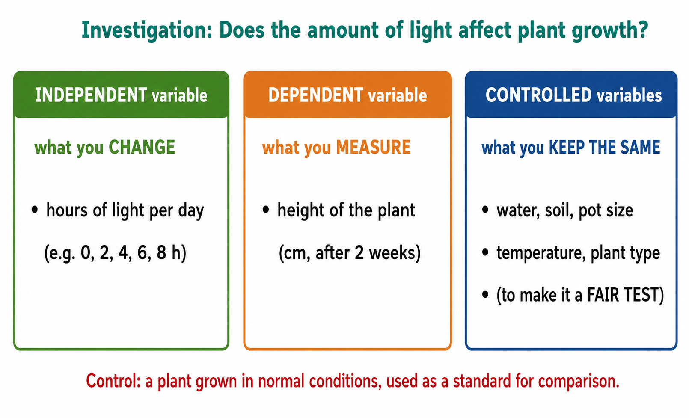
Figure 2: Variables in a fair test - change one (independent), measure one (dependent), keep the rest constant.

Reliability, Accuracy and Validity
Reliability, accuracy, and validity are important concepts used to evaluate the quality of scientific investigations and the trustworthiness of the results obtained.
Reliability refers to the consistency of results when an investigation is repeated under the same conditions. If similar results are obtained each time the experiment is conducted, the results are considered reliable. Reliability can be improved by conducting multiple trials, increasing the sample size, and calculating average values.
Accuracy refers to how close a measurement is to the true or accepted value. Accurate measurements depend on the use of appropriate equipment, correct measuring techniques, and careful observation. For example, a digital thermometer may provide more accurate temperature readings than estimating temperature by touch.
Validity refers to whether an investigation measures or tests what it is intended to investigate. A valid experiment uses an appropriate method, controls variables effectively, and collects relevant data that directly addresses the research question or hypothesis.
The table below summarizes the differences between these three concepts:

Concept | Meaning | How to Improve
Reliability | Consistency of results when repeated | Repeat trials and calculate averages
Accuracy | Closeness to the true value | Use suitable equipment and careful measurement
Validity | Whether the investigation tests the intended hypothesis | Control variables and use appropriate methods

Repeating measurements and calculating an average can improve reliability and reduce the influence of random errors. Scientists carefully evaluate reliability, accuracy, and validity to ensure that conclusions are based on high-quality evidence.

Processing and Analyzing Data
Once data has been collected, it must be organized and analyzed so that meaningful conclusions can be drawn. Raw data by itself provides limited information, but when arranged in tables, graphs, and charts, patterns and relationships become easier to identify.
Data is commonly recorded in tables that include clear headings, labels, and appropriate units of measurement. Organized tables help scientists compare results and identify trends within the data.
Scientists may collect two main types of data:
- Qualitative Data - descriptive observations recorded using words rather than numbers, such as color changes, odors, textures, or behaviors.
- Quantitative Data - numerical measurements obtained through counting or measuring, such as height, temperature, mass, time, or volume.
Graphs are often used to display data visually. The choice of graph depends on the type of data being presented:
- Line Graphs are used for continuous data, such as the relationship between temperature and enzyme activity.
- Bar Graphs are used to compare categories or groups of data.
- Pie Charts may be used to show proportions or percentages within a dataset.
By examining tables and graphs, scientists can identify trends, patterns, and relationships between variables. This process of interpreting results is known as data analysis and plays a crucial role in determining whether the evidence supports the original hypothesis.
Effective data processing and analysis allow scientists to make informed conclusions, evaluate the success of an investigation, and communicate findings clearly to others.
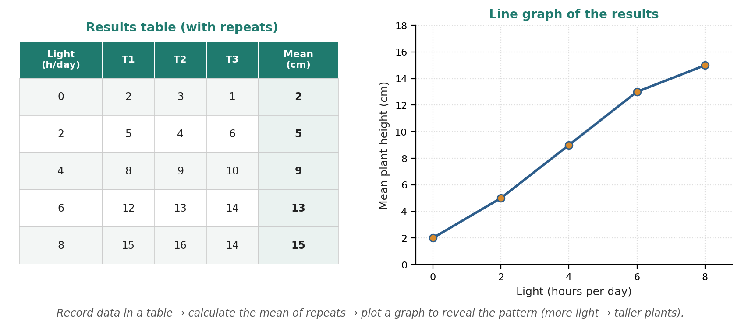

Figure 3: Turning raw data into a table and a graph reveals the trend in the results.

Communicating: The Scientific Report
Scientific investigations are only valuable when their methods, results, and conclusions can be shared and understood by others. Scientists communicate their findings through structured scientific reports, allowing other researchers to evaluate, verify, and repeat the investigation. Effective scientific communication promotes collaboration, transparency, and the advancement of scientific knowledge.
A scientific report is usually organized into several key sections:
- Aim - States the purpose of the investigation or the question being investigated.
- Hypothesis - Presents the proposed explanation or prediction being tested.
- Materials - Lists the equipment and resources used during the investigation.
- Method - Describes the procedure followed so that the investigation can be repeated accurately.
- Results - Presents the data collected, often using tables, graphs, or charts.
- Discussion - Interprets the results, identifies patterns or trends, evaluates reliability and validity, and discusses possible sources of error.
- Conclusion - Summarizes the findings and states whether the evidence supports the hypothesis.
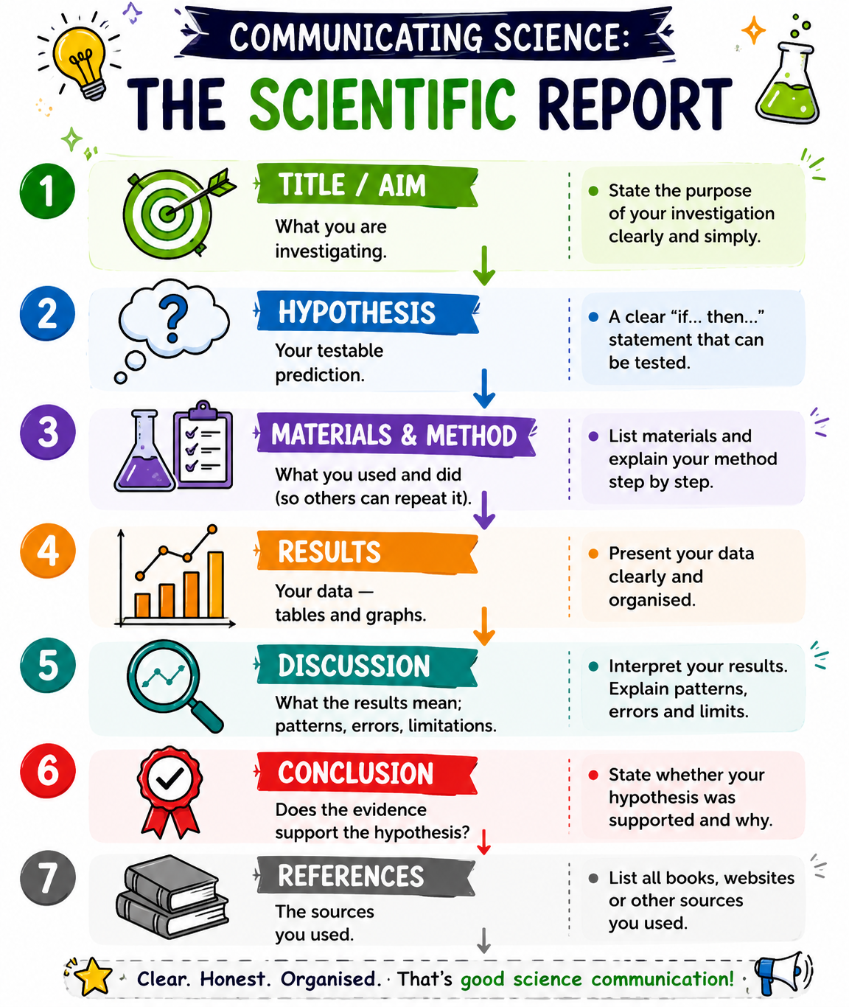
Good scientific communication requires clarity, accuracy, and honesty. Scientists must report all results objectively, including unexpected findings or results that do not support the original hypothesis. Recording and presenting information truthfully is essential for maintaining the integrity and credibility of scientific investigations.
By communicating results effectively, scientists contribute to the collective body of scientific knowledge and enable others to build upon previous discoveries.

Scientific Report Section | Purpose
Aim | States what is being investigated
Hypothesis | Predicts the expected outcome
Materials | Lists equipment and resources used
Method | Explains how the investigation was conducted
Results | Presents collected data and observations
Discussion | Interprets results and evaluates the investigation
Conclusion | States whether the hypothesis was supported

Worked Example - Designing a Fair Test
Research Question:
Does temperature affect the activity of the enzyme catalase?
Observation:
Enzymes are biological catalysts that help speed up chemical reactions. Their activity can be influenced by environmental factors such as temperature.
Hypothesis:
Catalase works most efficiently at approximately body temperature (37°C).
Prediction:
If the temperature increases towards 37°C, then the rate of oxygen production by catalase will increase. Above this temperature, the enzyme activity may decrease as the enzyme begins to denature.

Variables
Variable Type | Example
Independent Variable | Temperature
Dependent Variable | Rate of oxygen production
Controlled Variables | Enzyme concentration, substrate concentration, pH, volume, and reaction time
Control Group | A tube containing substrate but no enzyme

Method Summary
- Prepare identical catalase and substrate solutions.
- Set up test tubes at different temperatures.
- Measure the amount of oxygen produced over a fixed period.
- Repeat each temperature treatment three times.
- Calculate the average result for each temperature.
Expected Results
The rate of oxygen production is expected to increase as temperature rises towards 37°C and then decrease at higher temperatures due to enzyme denaturation.
Evaluation
Repeating the experiment three times and calculating an average improves the reliability of the results. Keeping all controlled variables constant helps ensure the investigation remains valid. Using accurate measuring equipment and following a consistent procedure improves the accuracy of the investigation.
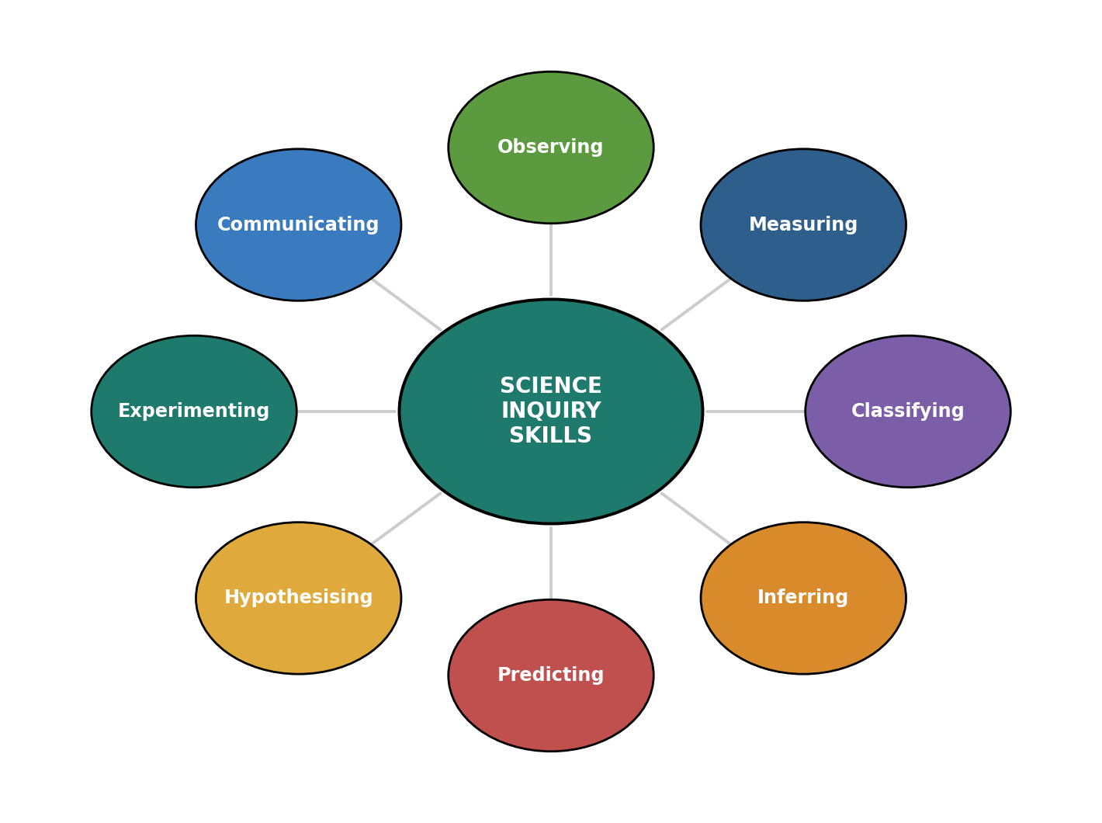
This investigation demonstrates the principles of a fair test by changing only one variable while carefully controlling all other factors that could influence the outcome.

Figure 4: The inquiry skills working together across a complete investigation.

PNG Context Example
Scientific inquiry skills can be applied to real-life situations in Papua New Guinea. For example, a student may investigate whether the amount of sunlight affects the growth of sweet potato plants in a school garden.
Question: Does sunlight affect sweet potato growth?
Hypothesis: Sweet potato plants receiving more sunlight will grow taller than plants receiving less sunlight.
By identifying variables, collecting measurements, analyzing results, and drawing conclusions, students can apply the scientific method to investigate questions relevant to agriculture and food production in Papua New Guinea.

Sources of Error and Improving Investigations
No scientific investigation is perfect. During an experiment, various factors may affect the accuracy, reliability, or validity of the results. These factors are known as sources of error.
Common sources of error include:
- Human Error - mistakes in measuring, recording data, or following procedures.
- Equipment Error - limitations or inaccuracies in measuring instruments.
- Environmental Factors - changes in temperature, light, humidity, or other conditions that may influence results.
- Sampling Error - using a sample that may not accurately represent the whole population.
Scientists evaluate their investigations to identify possible sources of error and determine how the investigation could be improved. Improvements may include increasing the number of trials, using more accurate equipment, improving control of variables, or increasing the sample size.
Identifying errors and suggesting improvements are important parts of scientific inquiry because they help increase the reliability and validity of future investigations.

Safety and Ethics in Scientific Investigations
Scientists have a responsibility to conduct investigations safely and ethically. During practical activities, students should follow laboratory safety rules, use equipment correctly, and report any accidents or hazards immediately.
Scientific investigations should also be conducted honestly and responsibly. Results must be recorded accurately without alteration, and living organisms should be treated with care and respect. Ethical scientific practices help ensure that investigations are safe, fair, and trustworthy.

Why Inquiry Skills Matter
Inquiry skills are at the heart of scientific learning and investigation. They enable scientists to ask meaningful questions, gather reliable evidence, analyze data, and draw conclusions based on facts rather than assumptions. These skills are not only important in biology but are also valuable in everyday life and future careers.
- Foundation of Scientific Knowledge - Every scientific discovery, from understanding cells and genetics to developing medicines and protecting ecosystems, is based on careful observation, investigation, and evidence-based reasoning.
- Critical Thinking and Problem-Solving - Inquiry skills help individuals evaluate information, identify reliable sources, interpret data, and make informed decisions. These skills are essential in a world where people are constantly exposed to information and claims from various sources.
- Practical Investigations and Assessment - Scientific investigations conducted in the classroom are assessed using inquiry skills such as planning, observing, measuring, analyzing, evaluating, and communicating findings. Developing these skills helps students become more confident and effective investigators.
- Preparation for Further Study and Careers - Inquiry skills are widely used in science, medicine, agriculture, environmental management, engineering, and many other fields. Learning how to investigate and solve problems prepares students for future education and employment opportunities.
By developing strong inquiry skills, students learn to think scientifically, solve problems systematically, and make evidence-based decisions that contribute to personal, community, and national development.

References & Related Documents

Source Documents
- Biology Standards-Based Syllabus, Grades 11 & 12 (PNG SBC 2020) - Strand 1: Science as Inquiry; Content Standard 12.1.1; Benchmarks 12.1.1.1–12.1.1.5.
- STEM Biology Student Resource Book - Grade 12. Scientific investigation and practical skills. Department of Education, PNG (2021).

Further Reading & References
- Alberts, B., et al. (2002). Molecular Biology of the Cell (4th Ed). Garland Science, New York.
- OpenStax Biology - https://openstax.org/books/biology
- National Human Genome Research Institute - https://www.genome.gov

